Test Connection.ps1

# Usage:

This script is used to test the connection to the SharePoint Environment for running the data oversharing script.

Note: This is a READ-ONLY script. It doesn’t make any changes to your tenant.

# Pre-requisites:

1. App Registration with following API permission. <https://learn.microsoft.com/en-us/sharepoint/dev/solution-guidance/security-apponly-azuread>
   1. SharePoint - Sites.FullControl.All
2. Certificate thumbprint. The PFX certificate should be installed into the executing machine.
3. Configuration text file in JSON format.

{

"AppId": "5a77792e-4cd0-4ac4-839f-b4a9c5e4f8c1",

"Thumbprint": "6DF3D32DA943DDDC0C905A56C2A9C688A1C45C5C",

"TenantName": "m365x27828082.onmicrosoft.com",

"AdminURL": "https://m365x27828082-admin.sharepoint.com"

]

}

Refer the sample configuration file below.



1. PnP.Powershell module installed on the machine to execute the script. [Installing PnP PowerShell | PnP PowerShell](https://pnp.github.io/powershell/articles/installation.html)

# Execution steps:

1. Prepare the configuration file as given in the pre-requisites.
2. Edit the script “**Test-Connection.ps1**” and update the below point the config file.

$configFilePath = "C:\temp\config.txt"

1. Open PowerShell as an administrator from the machine (make sure the **PnP.Powershell** module is installed) and execute the script.

C:\temp> & '.\Test-Connection.ps1'

# Output:

Successful connection will look like below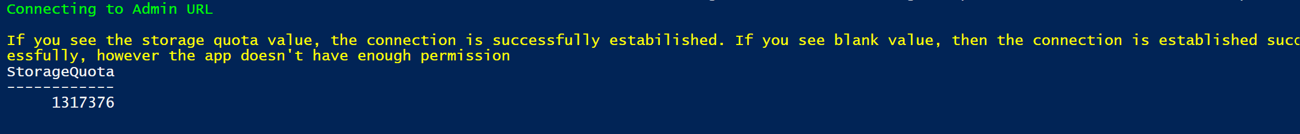

Failed connection will look like below with detailed error message which is helpful for next troubleshooting.

